**Môn: Phát Triển Ứng Dụng Cơ Sở Dữ Liệu 1**

**Họ tên: Ngô Kim Thư**

**MSSV: 1362111**

**Activity Diagram**

1. Activity diagram TraCuuDauSach

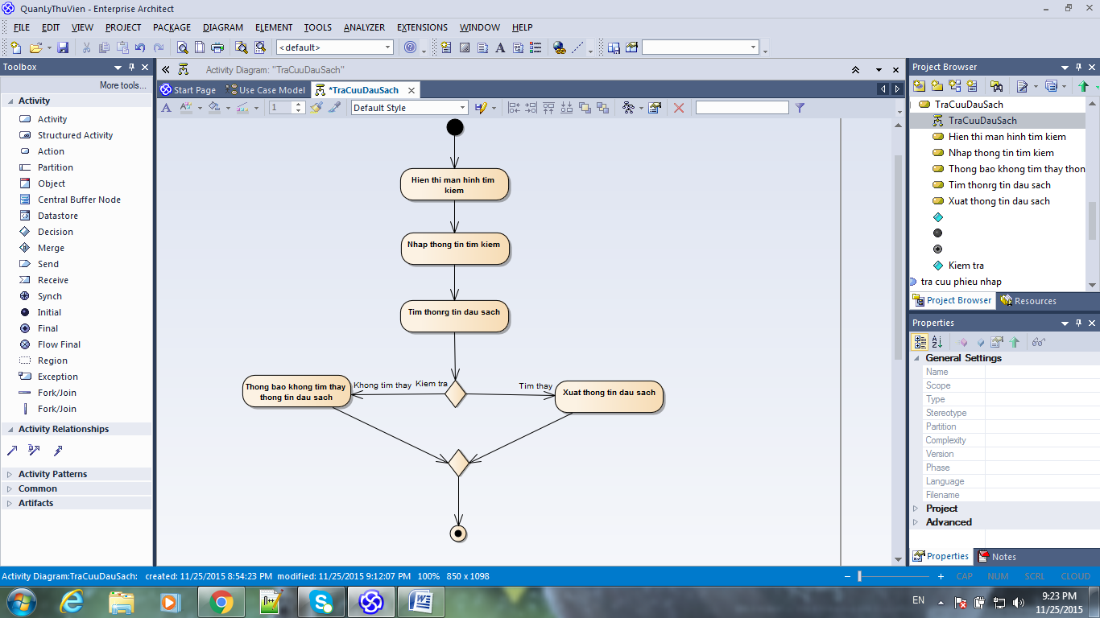

1. Activity diagram TraCuuThongTinQuyenSach

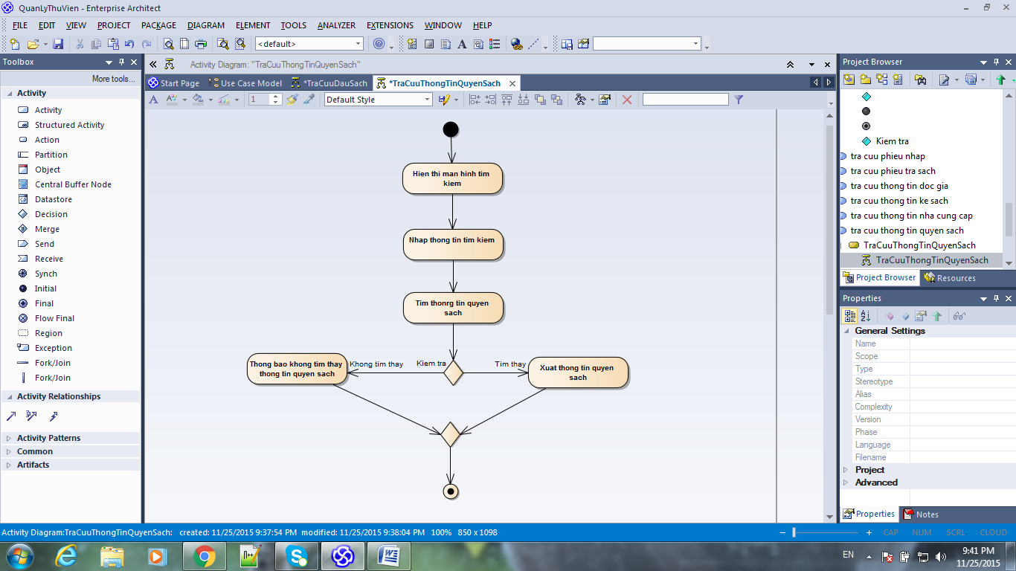

1. Activity diagram TraCuuThongTinKeSach

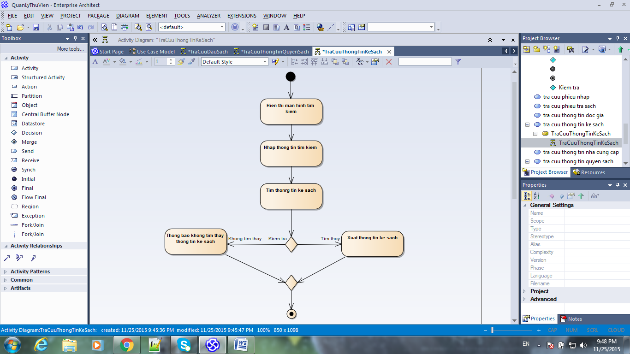

1. Activity diagram TraCuuThongTinNhaCungCap

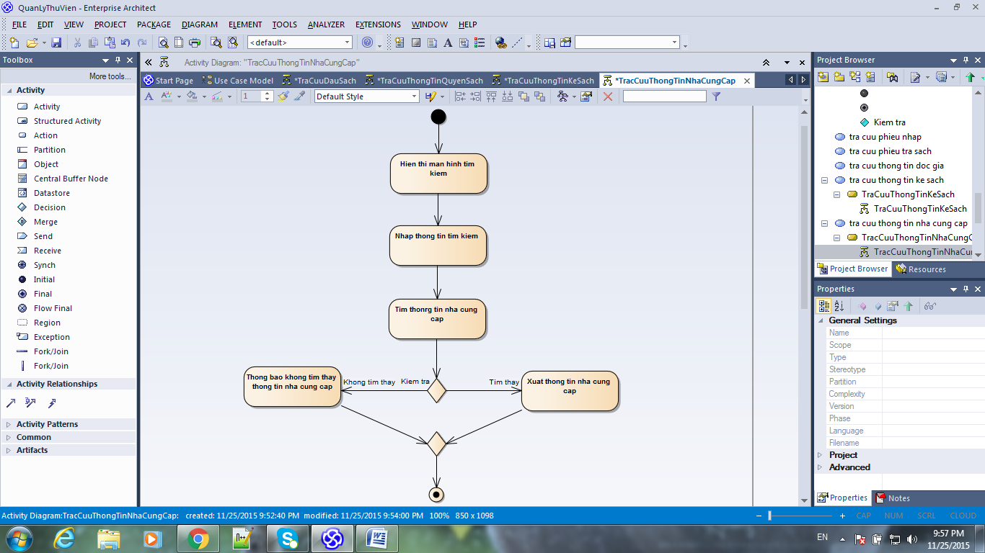

1. Activity diagram TraCuuThongTinDocGia

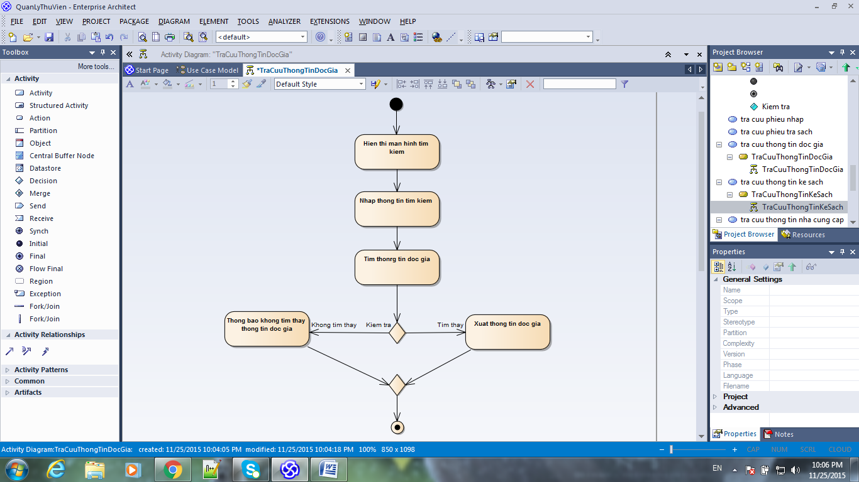

1. Activity diagram TraCuuPhieuNhap

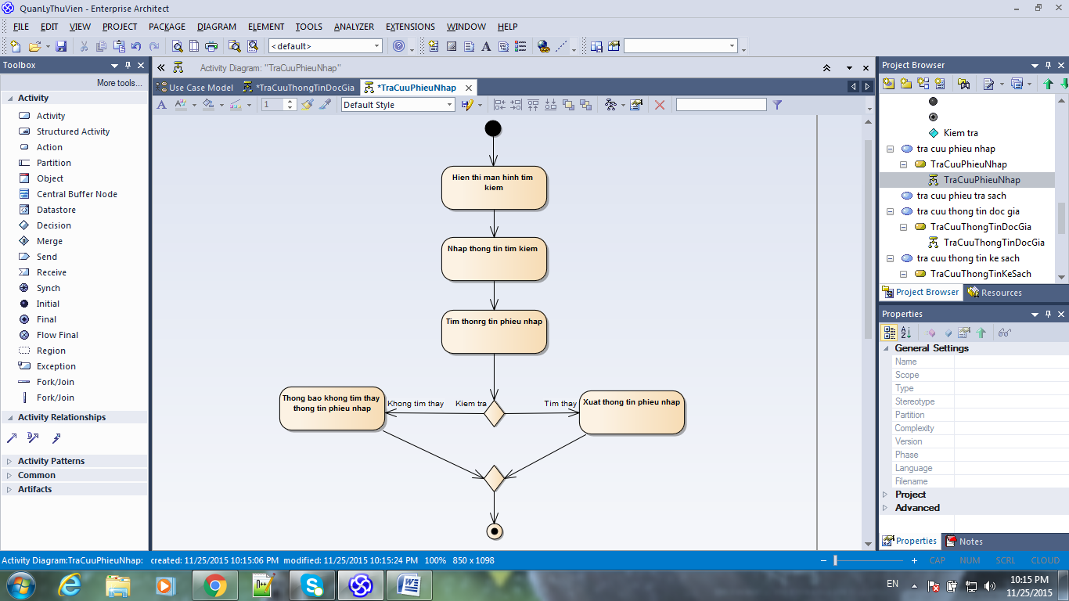

1. Activity diagram TraCuuPhieuTraSach

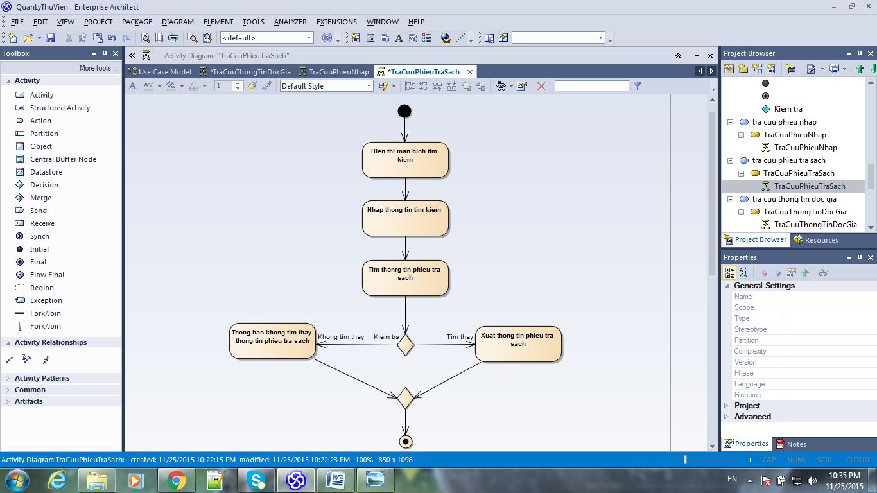

1. Activity diagram Login

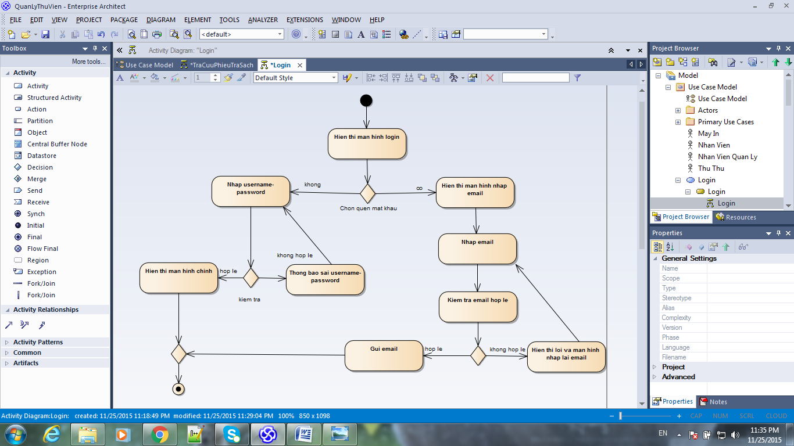

1. Activity diagram CapNhatThongTinDauSach

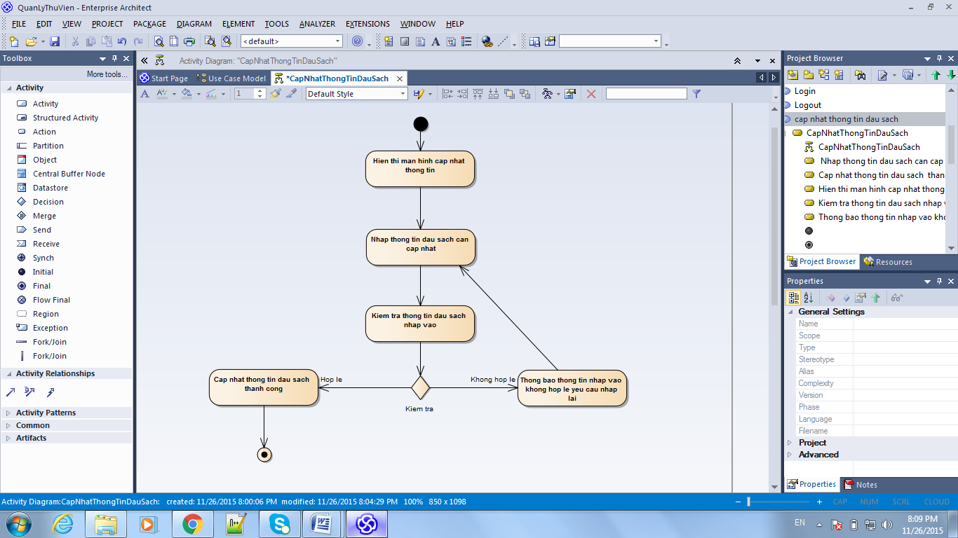

1. Activity diagram CapNhatThongTinQuyenSach

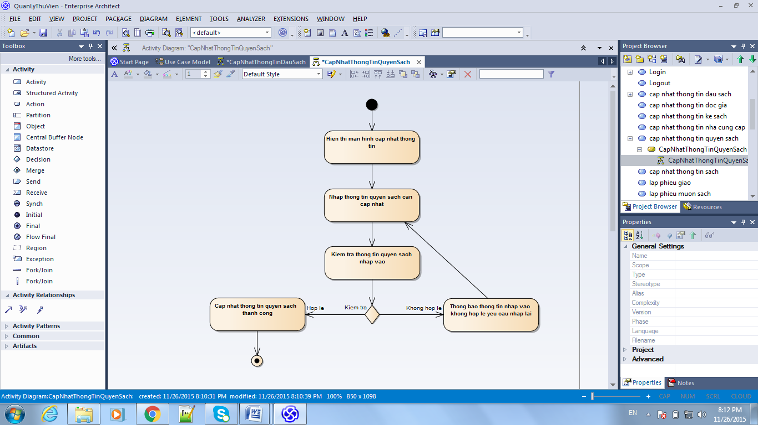

1. Activity diagram CapNhatThongTinKeSach

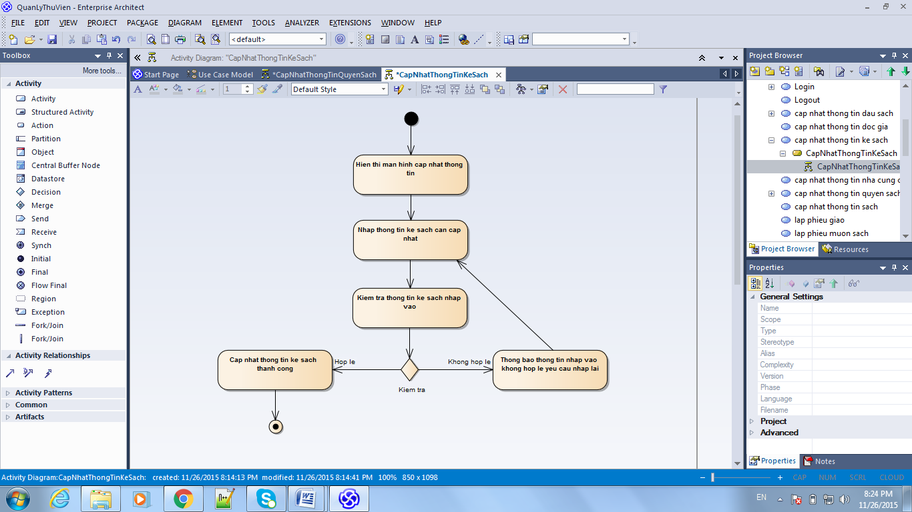

1. Activity diagram CapNhatThongTinCungCap

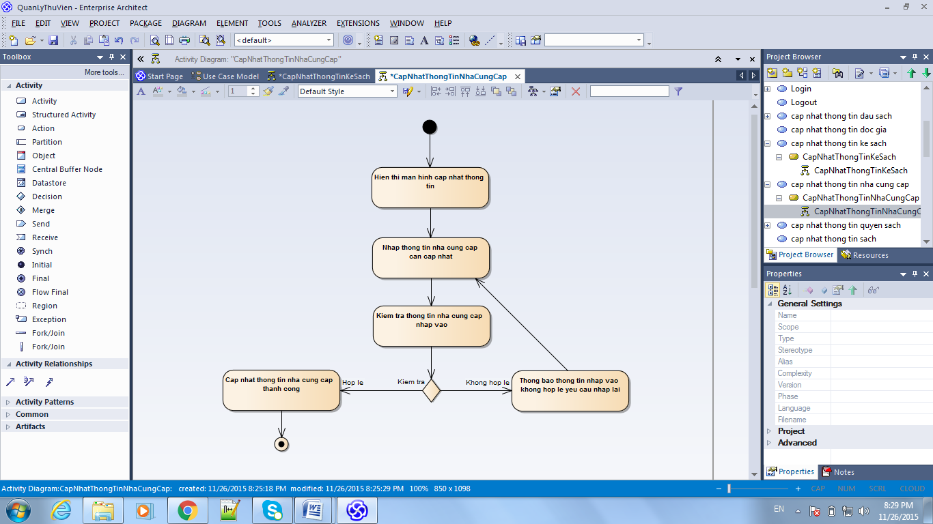

1. Activity diagram CapNhatThongTinDocGia

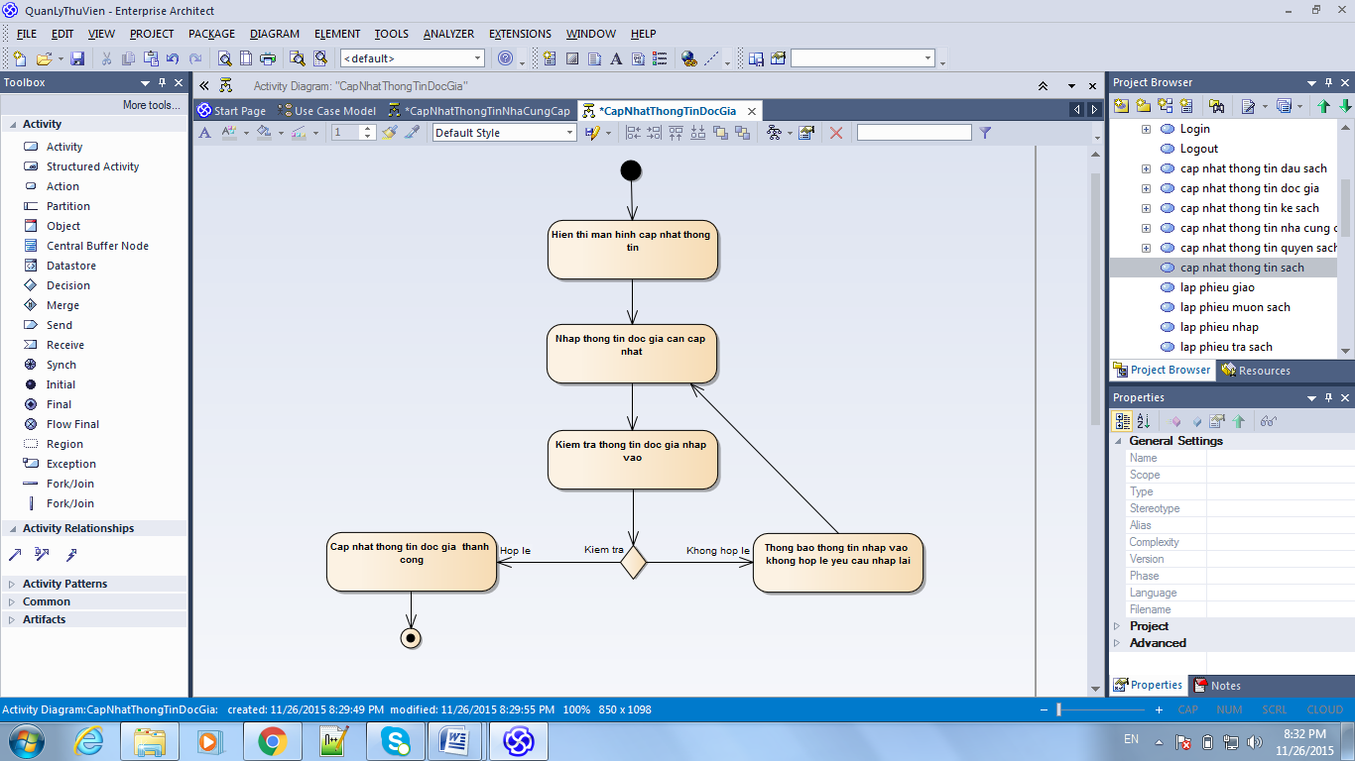

1. Activity diagram ThemMotNhaCungCap

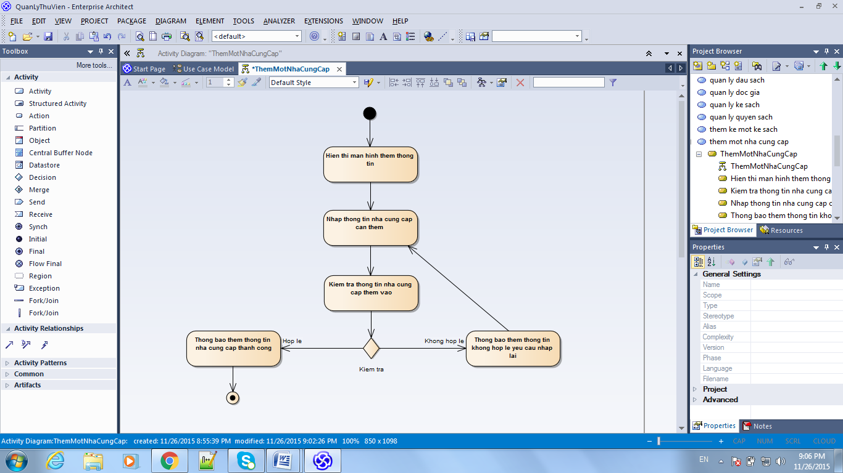

1. Activity diagram ThemMotKeSach

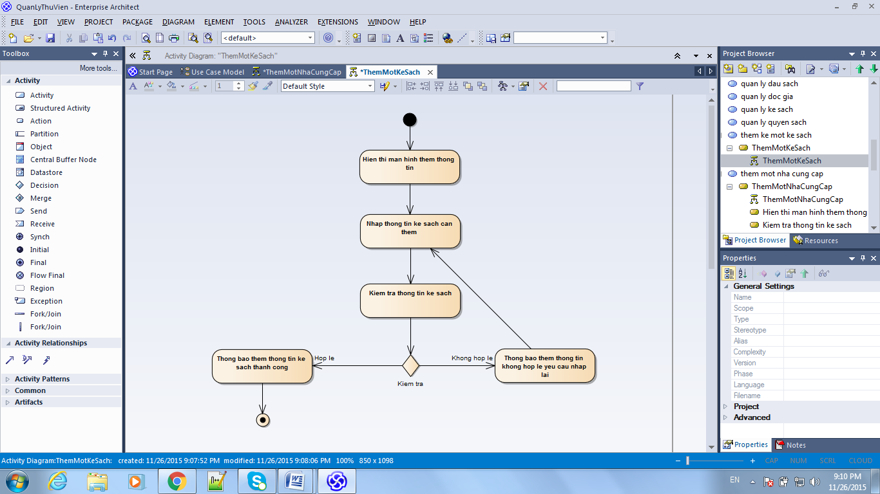

1. Activity diagram ThemMotQuyenSach

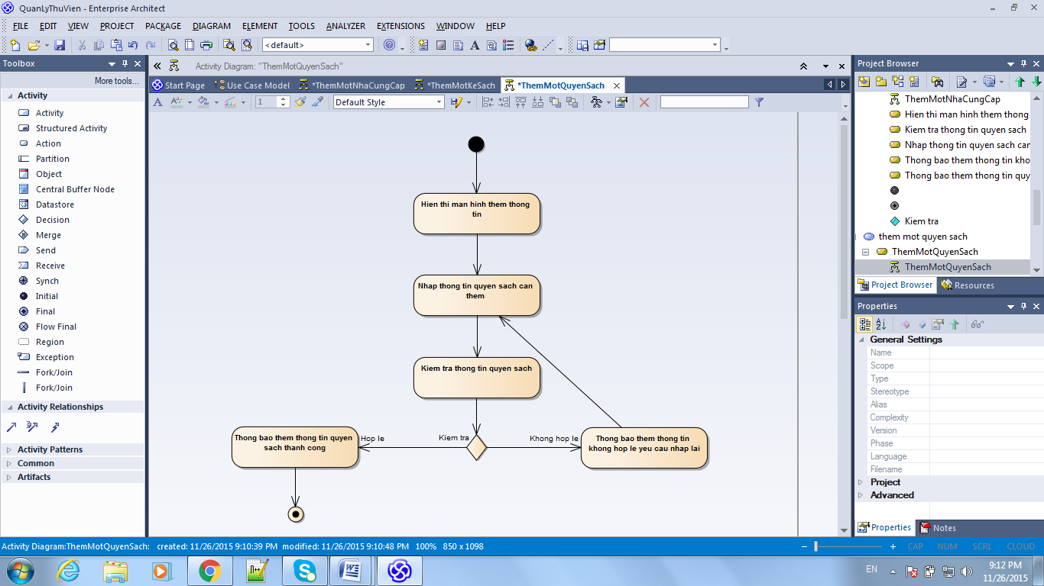

1. Activity diagram XoaThongTinDauSach

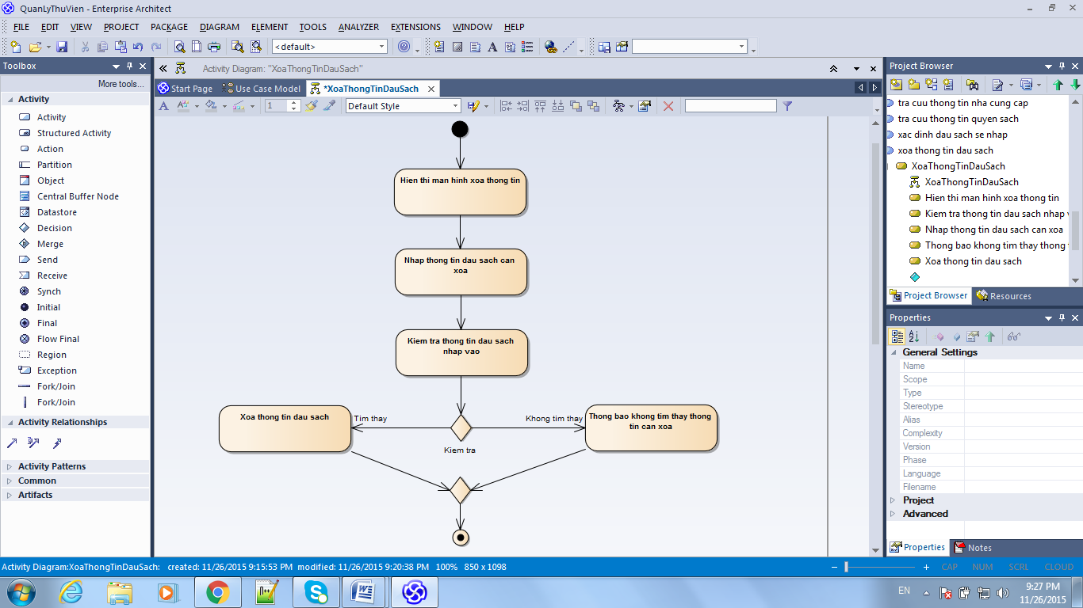

1. Activity diagram XoaThongTinQuyenSach

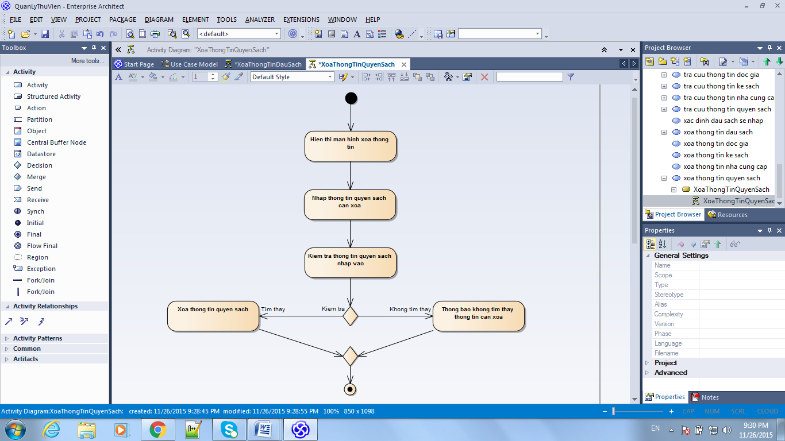

1. Activity diagram XoaThongTinKeSach

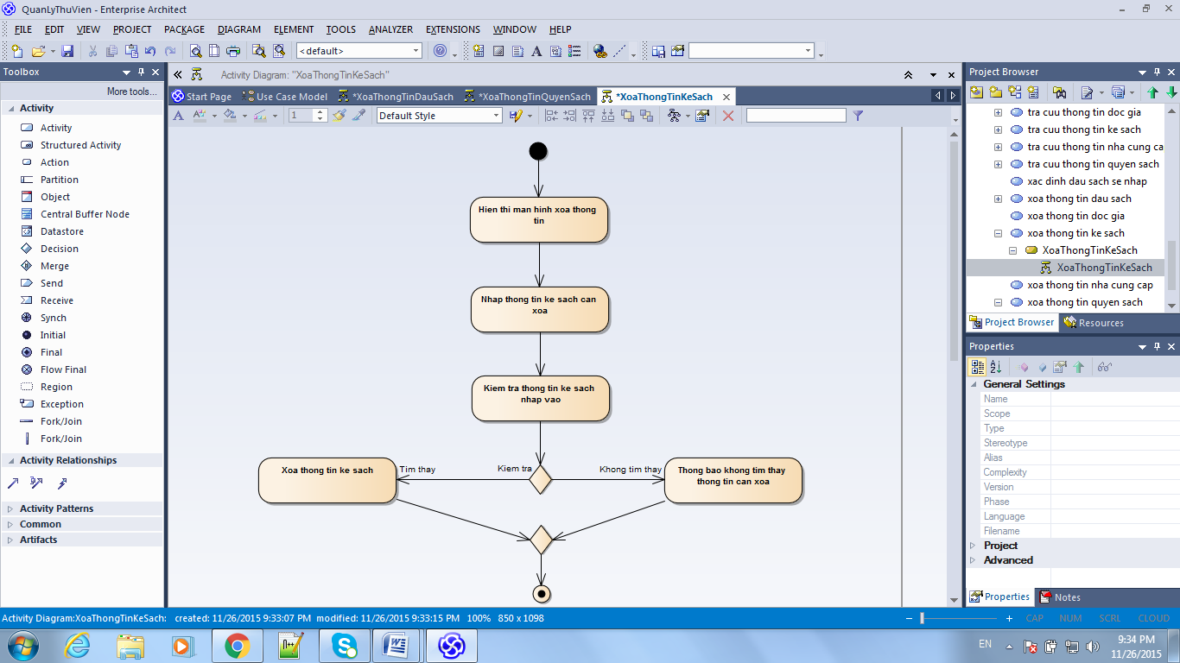

1. Activity diagram XoaThongTinNhaCungCap

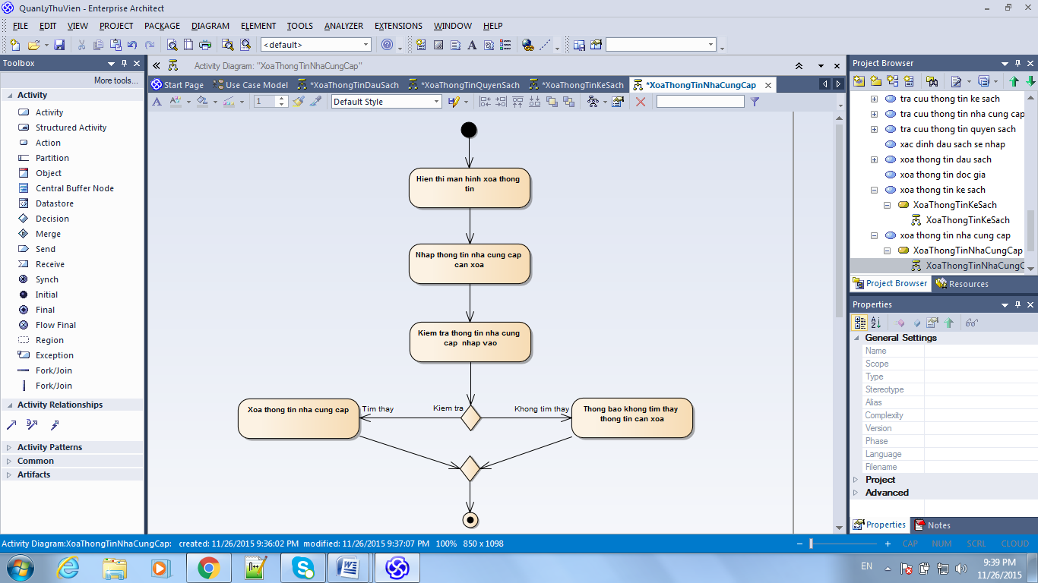

1. Activity diagram XoaThongTinDocGia

